**ANT: EC Sensor  
And Temperature Probe**

Jonah Gonzales

Automated Nutrient Technique (ANT)

October 26, 2021

**Intro:**

In this report, I am combining the DFRobot EC Sensor with the GikFun DS18B20 Temperature Probe. The two in tandem will allow us to get a proper EC reading, as temperature affects conductivity. With a proper temperature probe, I can now use it to get accurate temperature readings to properly adjust the conductivity, as opposed to using the 25 °C test value I used in the calibration.

**Expected temperatures for our use: ~20-22 ℃**

**Ideal EC range for our plants (Lettuce and beans) : 1.0-2.0 ms/cm**

**Schematic:**

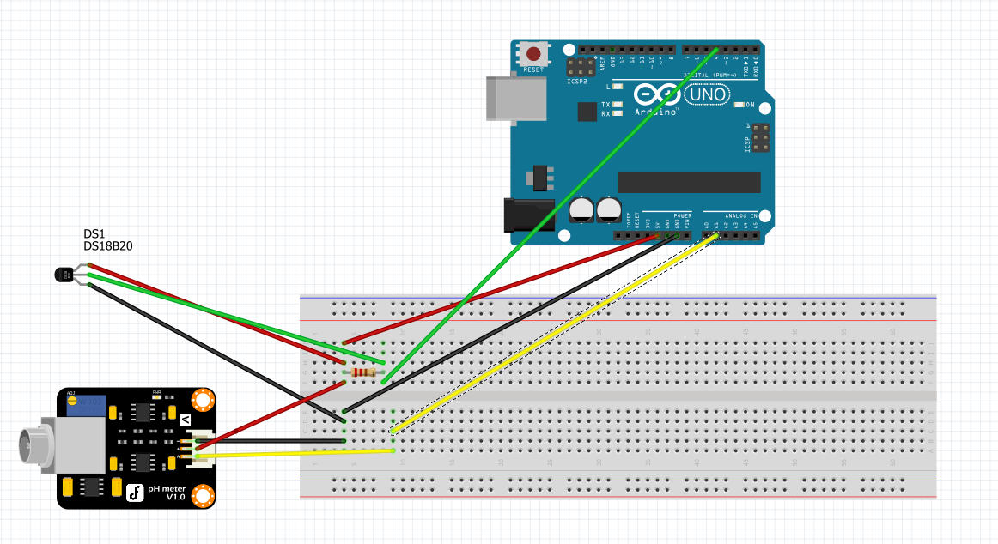

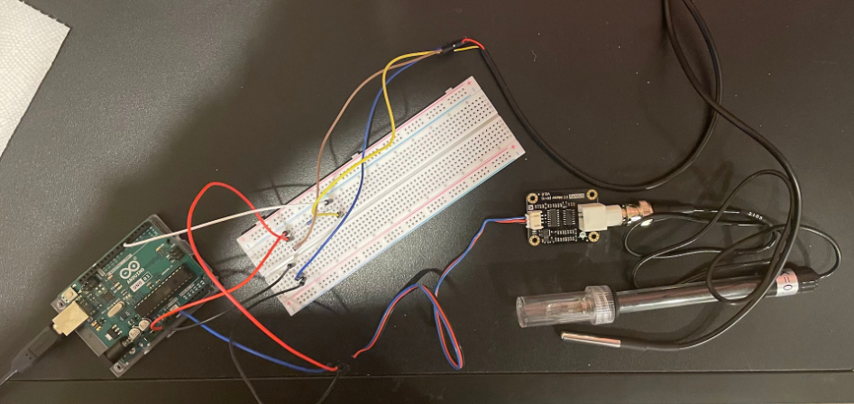

**Figure 1: Above: Schematic made using Figma. Below: Picture of sensor and probe connected to breadboard + Arduino**

**Code:**

#include "DFRobot_EC.h"

#include <EEPROM.h>

#include <OneWire.h>

#include <DallasTemperature.h>

#define EC_PIN A1

#define Temp_Sensor 4

float voltage,ecValue,temperature = 25;

DFRobot_EC ec;

OneWire oneWire(Temp_Sensor);

DallasTemperature sensors(&oneWire);

void setup() {

Serial.begin(115200);

ec.begin();

sensors.begin();

}

void loop()

{

static unsigned long timepoint = millis();

if(millis()-timepoint>1000U) //time interval: 1s

{

timepoint = millis();

voltage = analogRead(EC_PIN)/1024.0*5000; // read the voltage

//temperature = 25; //Temporary value until temp sensor added

temperature = readTemperature(); // read your temperature sensor to execute temperature compensation

ecValue = ec.readEC(voltage,temperature); // convert voltage to EC with temperature compensation

Serial.print("temperature:");

Serial.print(temperature,1);

Serial.print("^C EC:");

Serial.print(ecValue,2);

Serial.println("ms/cm");

}

ec.calibration(voltage,temperature); // calibration process by Serail CMD

}

float readTemperature() {

//Serial.print(" Requesting temperatures...");

sensors.requestTemperatures(); // Send the command to get temperature readings

//Serial.println("DONE");

/********************************************************************/

//Serial.print("Temperature is: ");

temperature = (sensors.getTempCByIndex(0)); // Why "byIndex"?

// You can have more than one DS18B20 on the same bus.

// 0 refers to the first IC on the wire

delay(1000);

return temperature;

}

**EC + Temp in 1413 us/cm**

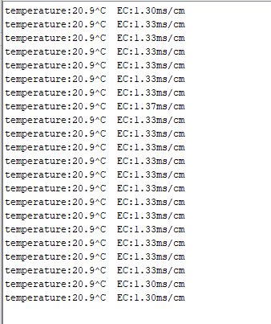

**Figure 2. Left: Temperature and EC Readings from Arduino Serial Monitor for 1413 us/cm test. Right: EC and Temperature probe in 1413 us/cm solution.**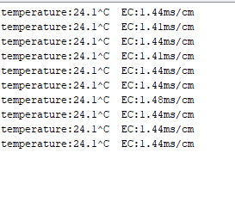

**Figure 3: Recalibrated EC Sensor (10/26)**

In the first test, the EC is lower than 1413 us/cm because the EC Sensor was calibrated at 25 C. This was intentional, as the lower temp should also be reflected by a lower conductivity, which was the case as shown in Figure 2. These values are closer to what we will be hoping to maintain during the actual growth process of our crops, so accuracy here is where we’re most concerned.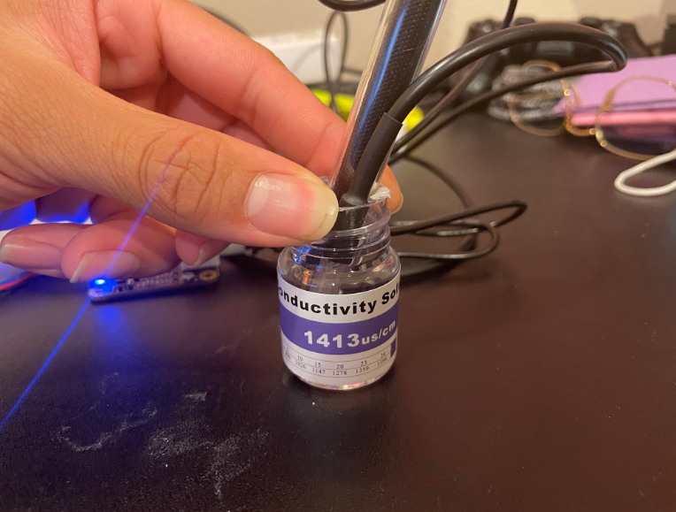

**EC + Temp Sensor in 12.88 ms/cm**

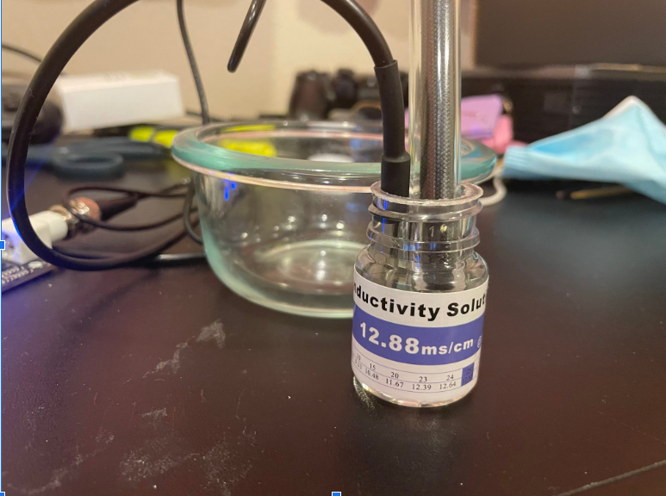

**Figure 3: Left: Serial Monitor from 12.88 ms/cm test. Right: EC sensor and Temp probe in 12.88 ms/cm.**

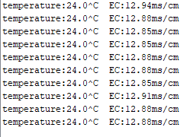

**Figure 4: Re-calibrated EC with the temperature probe (10/26).**

Again, in this test, the EC is slightly lower because the EC Sensor was initially calibrated at 25 C. Once again, this is reflected in the results as shown in Figure 3.

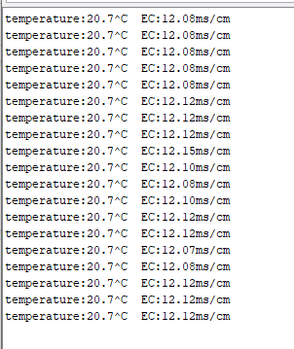

**EC + Temp Sensors in Tap Water**

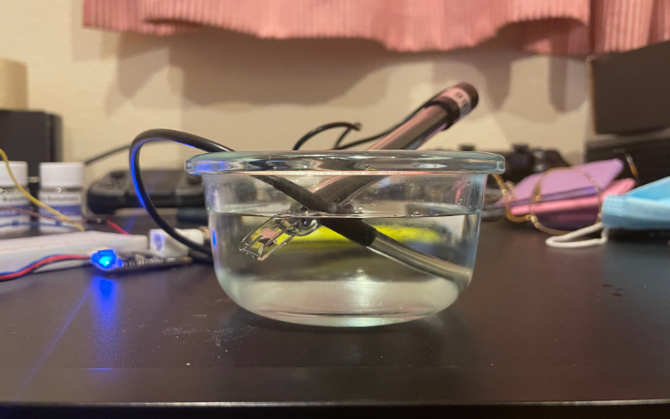

**Figure 4: Left: Serial monitor for tap water test. Right: EC sensor and Temperature probe in tap water.**

Tap water can range from 50 us/cm - 800 us/cm depending on the source (Aquaread). So the readings taken here fall right within that range.

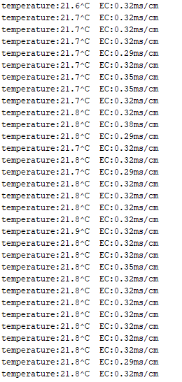

**EC Temp Sensors in microwaved Tap water**

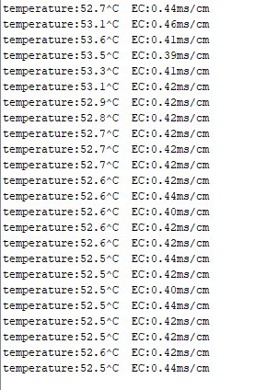

For this test, I microwaved the tap water for 30 seconds. This would show that the temperature sensor would read this increase, but also that the EC should increase as well, as conductivity is proportional to temperature.

**Conclusions:** Both sensors seem to be in fine working order. When actually implementing them into our system, for regulation purposes, we will probably want to take the average over x amount of data. As seen especially with the re-calibrated 1413 us/cm solution, the value kind of oscillated around the exact value. So if we take the average over a certain period of time, this might give us a better value to use when regulating the system measurements etc. The next step is to translate this to the ADC board so that the EC, Temp, and pH are all on the same system.

**Sources:**  
Average EC of tap water: https://www.aquaread.com/parameters/ec